LITTLEBOROUGH RUSHBEARING 19th - 22nd July 2018: Schedule
Thursday

Festival Team |  |  | Rushcart Team
When |  | What | When | What
 |  |  | By 18.00 | Welcome bargees, set up field and stalls
 |  |  | 17:00 – 18:00 | Cart collected on low loader from Birks Mill and brought to Warland for dressing
 |  |  | 18:00 – 22:00 | Rushcart dressing event hosted at Warland Farm
 |  |  | 21:00 | Cart taken to Littleborough Cricket Club for storage
Friday

Festival Team |  |  | Rushcart Team
When | What |  | When |  | What
 |  |  | 10.00 |  | Flotilla, music, dancing on barges from Warland to Summit Pub
 |  |  | 14.00 |  | Set up at Littleborough Cricket Club
 |  |  | 17:00 |  | Camping at Littleborough Cricket Club (outside scope of plan)  Cart dressing
 |  |  | 19.30 |  | Welcome event at Littleborough Cricket Club

Saturday

Festival Team |  | Rushcart Team
When | What | When | What
9.00 – 12.30 | Festival Get In at Park | 8.30 – 9.30 | Final cart dressing breakfast at Cricket Club
9.00 – 12.30 | Festival Get In at Park | 9.30 | Cart collected on low loader and taken to King Bill pub
9.00 – 12.30 | Festival Get In at Park | 9.30 – 10.00 | Dancers to King Bill pub
9.00 – 12.30 | Festival Get In at Park | 10.00 – 11.00 | Dancing at King Bill pub
9.00 – 12.30 | Festival Get In at Park | 11.00 – 11.30 | Cart parade from King Bill pub to St Barnabus Church
9.00 – 12.30 | Festival Get In at Park | 11.30 – 12.00 | Blessing and dancing at St Barnabus Church
12.30 – 13.30 | Littleborough Band on Bandstand | 12.00 – 12.30 | Parade from St Barnabus Church to Littleborough Square
13.00 – 14.30 | Vikings | 12.30 – 13.30 | Dancing and Mumming outside Wheatsheaf Pub
13.00 – 14.30 | Vikings | 13.45 – 14.00 | Parade from Square to Hare Hill Park
14.00– 15.00 | Cart arrival in Park. Turn and turn about at Harehill House | 14.00– 15.00 | Cart and procession arrive in Park: Dance turn and turn about outside Harehill House
15.00 – 15.15 | Youth folk groups at Band Stand | 15.30 | Bus trip round Littleborough?
15.15 | K stars | 15.30 | Bus trip round Littleborough?
16.00 | Vikings | 15.30 | Bus trip round Littleborough?
17.45 – 17.59 | Final dancing and cart parade leaves park | 17.45 – 17.59 | Final dancing and cart parade to Cricket
18.00 | Close | 17.30 – 20.00 | Rest
18.00 | Close | 20.00 | Singaround / music Session at Littleborough Con Club
Sunday

9.00 – 12.40 | Festival Get In at Square | 9.00 | Breakfast at Cricket
9.00 – 12.40 | Festival Get In at Square | 10.00 – 10.30 | Cart and dancers to wine press
9.00 – 12.40 | Festival Get In at Square | 10.30 – 11.15 | Dancing at Wine Press
9.00 – 12.40 | Festival Get In at Square | 11.30 - 12.30 | Parade from Wine Press to Waterside
9.00 – 12.40 | Festival Get In at Square | 12.30 – 12.50 | Dancing at Waterside  Meet Band and dignitaries at Waterside; continue parade to Littleborough square
13.00 – 14.00 | Cart arrives in square: Littleborough Band perform | 13.00 – 15:30 | Oakenhoof Dance The Littleborough at Main Square. Turn and Turn about with refreshments at The Oakenbar (stage 2)  SPLIT 6 sides and 6 between MAIN STAGE and Oakenbar AT 14.00
14.00 – 14.30 | Turn and Turn about in Littleborough Square | 15.30 | ALL TO MAIN STAGE AT 15.30
14.30 - 15.00 | Anderson Band | 15.30 | Parade mini cart to Holy Trinity Church: blessing, music and song at Church  ALL TO MAIN STAGE FOR 16.00 (Turn and Turn About for remaining sides)
15.00 – 15.30 | Az Kabile (check with Steve) | 17.30 – 18.00 | Remove cart to Con Car Park - undress
16.00 - 17.00 | Final dance at square then Close: Festival Get Out at Square; retire to Con for beer | 18.00 | Cart returns to Birks Mill
16.00 - 17.00 |  | 18.00 – closing time | Final session at Con Club
Dance sides
Thursday | Friday | Saturday | Sunday
Oakenhoof  Pannards  Rosso  Hill Millies  Thieving Magpie | Shamus O’Blivion and the Megadeth Morris Men  Les Pannards Dansant | Oakenhoof  Kirkholt K stars  Thieving Magpie  Chelmsford Ladies  Customs & Exiles  Horwich (?)  Raving Maes(?)  Cadi Ha(?)  (need to check with Mark) – Rossendale Mummers  (not parading – will meet at Shef)  Ryburn  Sheffield Uni  Hill Millies  400 Roses  (not parading – book for park)  Littleborough Band  Youth folk groups  LEAP TO YOUR FEET??  Vikings (I think they’re booked) | Oakenhoof  Thieving Magpie  Chelmsford Ladies  Customs & Exiles  Horwich PMMM  Raving Maes(?)  Cadi Ha(?)  Britannia Coconutters(?)  Rossendale Clog Heritage  (need to check with Steve L) Az Kabile  Ryburn  Sheffield Uni Morris

Event Plan

2018 Rushbearing Festival in Littleborough

Presented by

Littleborough Events and Associations Forum (LEAF) and Littleborough Oakenhoof Voluntary Arts Organisation supported by Rochdale Council.
Event Application Form reference:

Plan Status – Version 1: January 2018)
Saturday morning route:
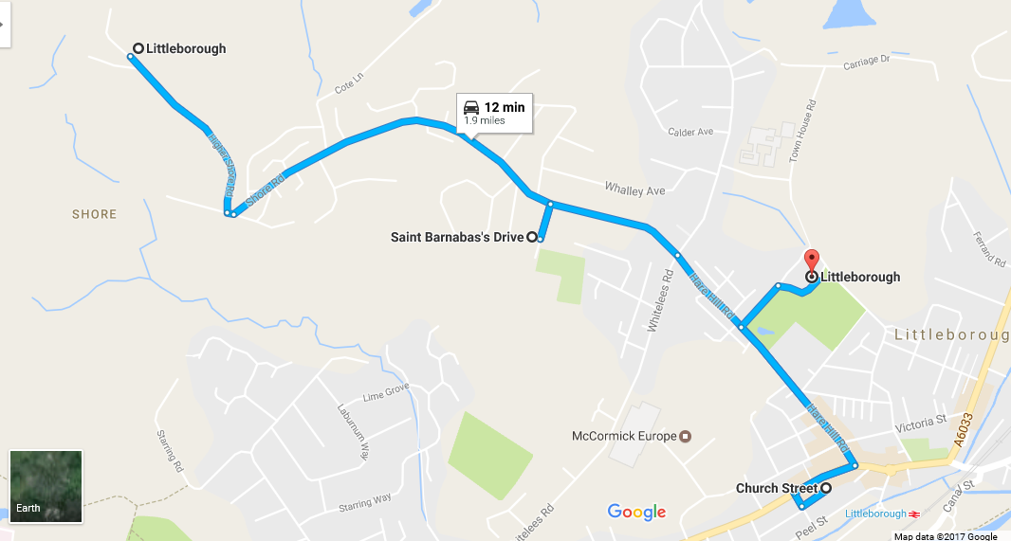
1
4
3
2
Ref | Location
1 | King Bill Pub: OL15 9LW
2 | St Barnabus Church: OL15 8EJ
3 | Wheatsheaf Pub: OL15 8AB
4 | Hare Hill Park: OL15 9HF

Sunday morning route:

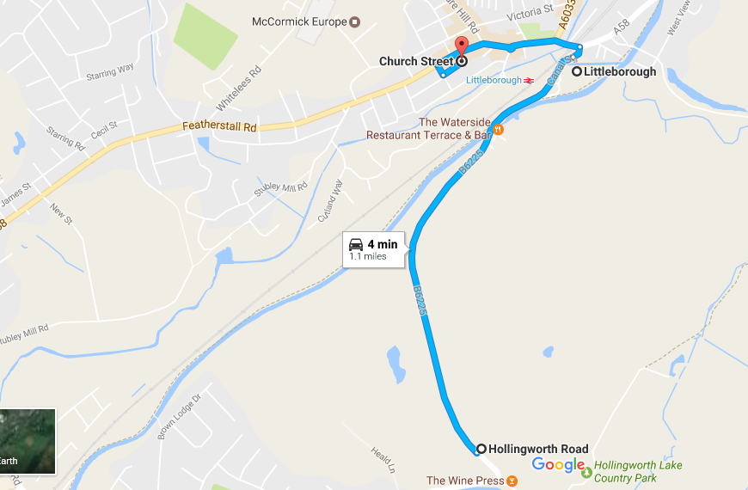
1
2
3
Ref | Location
1 | The Wine Press: OL15 0AZ
2 | Canal Car Park: OL15 0HA
3 | The Square: OL15 8AB

Festival Map

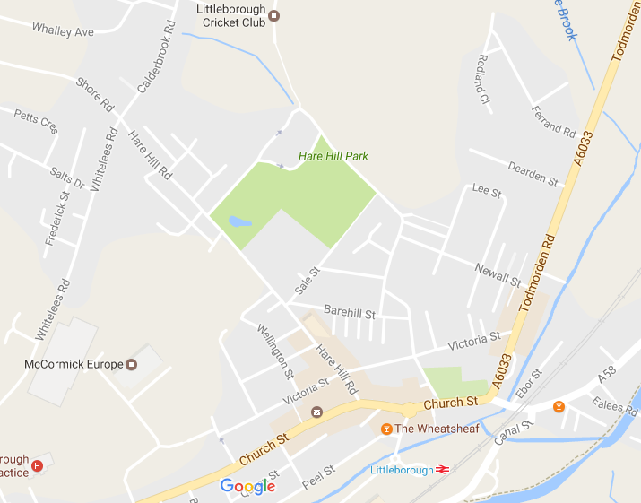
6
9
3
4
1
5
2
8
7
Ref | Location
1 | Warland Farm: OL15 6XA
2 | Cricket Club: OL15 9LD
3 | King Bill: OL15 9LW
4 | St Barnabus: OL15 8EJ
5 | Wheatsheaf (The Shef): OL15 8AB
6 | Hare Hill Park: OL15 9HF
7 | Con Club: OL15 8AQ
8 | Wine Press: OL15 0AZ
9 | Holy Trinity: OL15 9DB

1. Introduction

This is the festival plan for the Littleborough Rushbearing; an annual event, which dates back to the times when buildings had earth floors and rushes were collected to be placed on the floors to keep buildings warm in the winter. This process became a tradition and soon a festival, which was widespread in many parts of Britain by the 16th Century. It became revived in the 19th Century and Littleborough, along with many other villages in the Rochdale area had a vibrant festival. Littleborough is now one of only a few areas in the country which still holds a Rushbearing Festival. Traditionally, Rushbearing festivals were held on a Sunday, and though the main procession and dancing will take place on a Sunday, we also have activities taking place over the whole weekend, to celebrate our tradition. All our events are free and there will be no alcohol included in our plans.

2. General Information

Name of Event | Littleborough Rushbearing Festival
Date of Event | 19th - 22nd July 2018
Venue | Hare Hill Park, and “the Square,” Littleborough
Grid reference | Lattitude: 53.6468  Longitude: 53.6468
Event Times | Friday 17.00-21.00.  Saturday and Sunday, 12.00- 18.00
Cost | Free
Attendance | 1000 (max at any one time)

The audience profile is expected to be family groups.

3. License type and objectives
Events applications have been submitted.

General
The following points set out the intention of LEAF, a voluntary community group, for this event. Below is a summary of our intentions.

We shall
- Provide a comprehensive event plan
- Produce a comprehensive risk assessment and implement any recommendations
- Ensure the provision of sufficient first aid and stewards
- Ensure the provision of adequate PL insurance
- Ensure all vendors are competent and have adequate PL insurance
- Brief all staff and stewards thoroughly

The prevention of crime and disorder
- Programme suitable acts and entertainment that will not attract an audience that are likely to cause disorder
- Ensure that acts and entertainment are suitable for the audience and do not incite disorder
- Provide properly trained volunteer stewards for the purposes of signposting and information
- Produce an Event plan
- Follow any advice provided by the Council’s teams.

Public safety
- Each element of the event should be designed to be intrinsically safe
- A full risk assessment will be produced and risks reduced wherever possible
- An event plan to include contingency plans will be produced
- Staff and stewards will be thoroughly briefed
- Emergency services will be contacted and their advice followed
- Adequate first aid provision will be provided

The prevention of public nuisance
- Programme suitable acts and entertainment according to the site and time of day
- Ensure that music is unamplified or with minimal amplification to ensure safe sound levels
- Use competent volunteers to operate sound systems
- Only build on site during reasonable hours
- Produce a build schedule to avoid nuisance

The protection of children from harm
- Write and implement a child protection policy within the plan
- Train volunteers in child protection where necessary
- Include a policy for dealing with lost children in the event plan
- Brief staff and stewards on plans and policies
- Design the site to help protect children, this may include barriers or cordons

4. Key event roles
Name/Role | Location
Event Manager.  Steve Lister: 01706 373371/ 07770 595730 | Site wide | Event Manager  - Manage event volunteers and resources  - Make strategic decisions regarding delay or cancellation of elements of the event  - Oversee co-ordination and timing of event elements across the site  - If the Event Manager is unavailable, the above duties will be undertaken by the Deputy Event Manager  - Co-ordinating any announcements to be made
Support from Rochdale Borough Council | N/A | Council Support for the event  - Prior to the event, check Event plan and risk assessments and instruct should corrective action need to be taken
Head of Security and Stewarding. Damien Maguire 07970 896619 | site wide | Head of Security and stewarding  - Responsible for drawing up a schedule of stewarding for the event  - Running pre-event briefing for all stewards  - Equipping and monitoring all stewards at the event  - Overseeing deployment of staff and resources  - Carrying out agreed contingency plan procedures as advised by the Event Manager and Safety Officer
First aid provider: Volunteers of LEAF and Oakenhoof. Coordinated by Dave Broome 07985 332495 | site wide | Medical Co-ordinator  - Responsible for co-ordinating medical cover across the event site  - Advise the Event Manager on medical issues and the activation of contingency plans.
Traffic Manager. Damien Maguire 07970 896619 | site wide | Traffic manager  - To co ordinate and implement traffic management plan
Compere / announcer. John Kay | site wide | Compere / announcer  - Announce all acts / activities as they are available  - Pass on any information to attendees.
Suppliers on Site | Hare Hill Park, Littleborough square | Greenwood’s Bakery BBQ,  Street Eat (Van)  Drum and Baste Pizzas,  Harry’s Pork Hog Roast  Fabio’s Ices  Do-Nuts  Harry’s Burgers (provided by Fun Fair)
Performers - contacts:  Steve Lister (07770 595730)  Helen Chicot (07951 159 586) | HHP band stand, procession and square | Oakenhoof  Thieving Magpie  Chelmsford Morris  Customs & Exiles  400 Roses  Rossendale Clog  Hill Millies  Vikings  K Stars  Ryburn 3 Step  Rossendale Mummers  Horwich Prize Medal Morris Men  Brittannia Coconutters  Az Kabili

- Crowd Management, stewarding and guarding
Volunteer Stewards, who will have an ambassadorial role for information and welfare. We expect a minimum of 15 stewards on site at any one time during the two main elements of the festival (Saturday and Sunday afternoon).

- Facilities for people with disabilities
The park and village is accessible and egress points will be suitable for disabled people.
Accessible toilets are available for customers of local pubs / cafes.

- Communication

Mobile phones will be used for communication on site. Numbers can be found in this plan at point 7.

Radios will be used by stewards.

Channel allocation:

One | Event control and senior staff
Two | Stewards
Three | Production
Four | Entertainment
Five | Medical
Six | Emergency channel

The Emergency Channel shall be kept clear of normal traffic. Should an incident require the Event Manager to talk to a particular location or individual without interruption from other users, they will instruct the correspondent to switch radio channels to the Emergency Channel. Once the incident has been resolved, all parties shall be instructed to return to their normal operating frequency, leaving the Emergency Channel clear once again.

The PA will be used in the event that there is a need to make emergency announcements.
Mobile phone numbers can be found on the cover of this plan and in the management structure on pages 7-8.

- Temporary demountable structures
Food vendors and craft activities have small structures such as gazebos.

- Stages
A permanent stage (Hare Hill Park Band stand) will be used.

- Electricity systems
Mains operated PA, for bands and announcer, with roaming microphone provided by Friends of Hare Hill Park and controlled by David Woodhead

- Emergency lighting
All activities included in this plan take place in daylight hours.

- Sound and noise
There will be a small amount of sound / noise from the performers at the Park and in the village. This will include unamplified / minimal amplification folk, brass, vocal and drumming.

Local residents and adjacent businesses have been informed of these plans by consultation and direct mail shot.

- Overnight Security
All equipment and structures will be off site (or locked at the Cricket Club) overnight.

- Fire Safety
GMFRS have been alerted to the event.
An event application has been submitted to the Council. Advice is sought whether Environmental Management need to undertake a fire risk assessment.
Caterers will provide individual fire risk assessments.

- Emergency procedures
Emergency procedures and major incidents will be dealt with by the Event manager. In the event of an incident as defined under the Civil contingencies act 2004, one of the responsible services may take primacy.

Fire in any area
- Move people away from the fire in a calm and polite manner using announcements from a sound system or loud hailer using the script for evacuation below.
- Communicate by radio or in person the exact location of the fire to the event manager and safety officer, use the code word “MR FROST” is required and state the location clearly. The Event Manager AND Safety Officer will call the fire service stating the location of the fire.
- Stewards on the red route access will be informed and if necessary a response team will be dispatched to walk emergency vehicles onto site to assist with crowd control.
- Tackle the fire using appropriate methods ONLY if it is safe to do so and you have received fire safety training. DO NOT TAKE RISKS!
- The event safety steward will assess the implication on the continuation of the event and a log of the incident will be made
- In the event of a major incident the event will be passed to the emergency services

- Overcrowding
Careful consideration has been taken to assess the event space in relation to expected audience numbers and a maximum occupancy has been established.
The crowd will be monitored during the build up, event and egress.
This is a relatively small event, with no more than 1000 people expected at any one time (assumption based on previous events).
This assumption will be reviewed annually and event plans altered accordingly.

Evacuation
It may be necessary to evacuate the site. The Event Manager, in consultation safety steward and emergency services, will make this decision. In an extreme situation emergency services may take supremacy.

If an evacuation or a cordon is to be made stewards will be placed on alert to prepare for an evacuation using the radio call telling them to be on AMBER ALERT. All stewards should make their way to their allocated positions, where possible maintain radio silence and listen for further commands. If an evacuation is required stewards will be alerted with a RED ALERT message where stewards will direct people to the nearest exit. At any point a stand down alert using GREEN ALERT may be used, at this point stewards will resume their normal duties.
On a Red Alert stewards will be briefed and an announcement will be made and repeated over the sound system or loud hailer using the following script:

ATTENTION PLEASE. ATTENTION PLEASE. FOR YOUR OWN SAFETY IT IS NECESSARY TO EVACUATE (NAME OF THE AREA TO BE CLEARED). PLEASE MAKE YOUR WAY TO (NAMED AREA OF THE SITE). (IT MAY ALSO BE NECESSARY TO ASK PEOPLE TO MOVE ON FOOT AND NOT TAKE THEIR CARS). THANK YOU.

It may be necessary not to use one or more of the egress routes, this will be announced during the evacuation speech, and people should be directed to leave accordingly.
Stewards will calmly and politely assist with the evacuation, the area will be checked and a log will be made of the incident.
On large sites it may not be necessary to fully evacuate the site but simply to move the audience away from the incident.

Steward and volunteer rendezvous point:
The RV for staff will be Hare Hill House front entrance on the Saturday and the Conservative Club car park on the Sunday. If this is not possible, alternatives will be communicated by mobile phone / radios.

Emergency services RV point:
RV for emergency services will be Town House Road on the Saturday; Village centre on the Sunday.

- Traffic management

An event application, including application for temporary road closure has been submitted.

- Medical/first aid provisions

Trained first aid volunteers will be provided. Working within the guidelines of a minimum of 2 first aiders per 1000 people, we intend to have 4 first aiders on site at all times, including one trained in paediatric first aid.
The nearest hospital is Rochdale infirmary, Whitehall st, Rochdale, OL12 0NB
Tel 01706 377777

- Information and welfare
Stewards and staff will be fully briefed on what to do in the event of an emergency or if the audience need information in relation to lost children or first aid.
A control position and information point will be signed and staffed.

- Lost children
All lost children must be reported to the Event Manager or Event Control. Lost children will be taken to the Child Safety Point . The Child Safety Point will be clearly marked at the craft marquee run by Janine Rez. Liels Beckles will assist.
They will also be briefed on the policies and procedures regarding ‘lost children’ and a log sheet will be produced.

Policy for stewards / volunteers is as follows: (in accordance with the Children’s act 1989)

If you are approached by a parent I guardian who has lost a child:
- Reassure the parents/guardian and inform them of the lost child procedure.
- Ask for a detailed description of the child; name, age, height, build, clothing etc.
- Ascertain where the child was last seen/located.
- Ascertain whether the child is with anyone i.e. friends, relatives.
- Ascertain where the family/group has been during the event
- Announcements giving descriptions of lost children will not be made over public address systems for child protection reasons.

If you are approached by a child who is lost:
- Reassure the child, tell them your name and who you are.
- Ask the child their name, age and their family name if possible.
- Ask the child if they have a phone number for their guardian.
- Report the lost child to the Event Manager but do not give out details of the child over an un secure radio network or any sound system. If in doubt, switch to the emergency channel. Use the code word “Disney” to relate to a lost child
- Find out where the child last saw their parents/guardian if possible.
- Remain with the child in the area you find them incase the parents/guardians are close by. Then if not collected after a reasonable time, take them to the Child Safety Point at the Punch and Judy stand.
- Remember child protection, use common sense and do not put your self at risk of accusation. Do not use inappropriate behavior and make sure that as soon as is possible there are two people dealing with one child.
- The child’s description will be passed around the stewards on a secure radio network or by moving to the emergency channel.
- Announcements requesting parents can be made if their names are known but no reference should be made to lost children. IE “Would Helen Baxter please come to Hare Hill House”
- A positive identification should be given by anyone claiming a lost child and a log of their name, address and description made before a child is reunited.
- If a child is reluctant to go with the guardian or does not recognize them the matter must be referred to the Event Manager who may involve the Police.

IMPORTANT - DO NOT FORGET TO REPORT THAT CHILD PARENT/GUARDIAN HAVE BEEN RE-UNITED!

- Food, refreshment and drinking water
Give details of food and drink provision
Food and drink will be available from the various vendors. On Saturday A public drinking water point will be provided for free drinking water will be available in Hare Hill House. On Sunday there several cafes and public houses around the square as well as the Catering Van provided by the fun fair and Fabio’s Ice Cream.

- Sanitary accommodation
Toilet facilities are available at local pubs, restaurants and cafes.

- Waste disposal
Removal of refuse produced by the Event
Waste will be removed by the festival volunteers

Normal Refuse Removal from the Site Footprint
The event will not disrupt the normal refuse collection service in the area of the footprint.

Street Cleaning
The usual service will not be interrupted.

24. Itinerary

Please see front sheet for a full itinerary of each of the event dates.

- Build schedule
Included with the itinerary at appendix 5

- Appendices

- Event Risk Assessment
- First aid score sheet
- Site plan
- Traffic management plan
- Build schedule
- Itinerary
- Assumption form

Appendix 1. Event Risk Assessment

Please see separate Excel spreadsheet, with separate worksheets for the three different elements of the event:
- Cart dressing and performers’ camping
- Events in Hare Hill Park
- Rushbearing parade and performances in Littleborough

Appendix 2: First aid score sheet

Appendix 3: Site plans

Saturday events in the park:

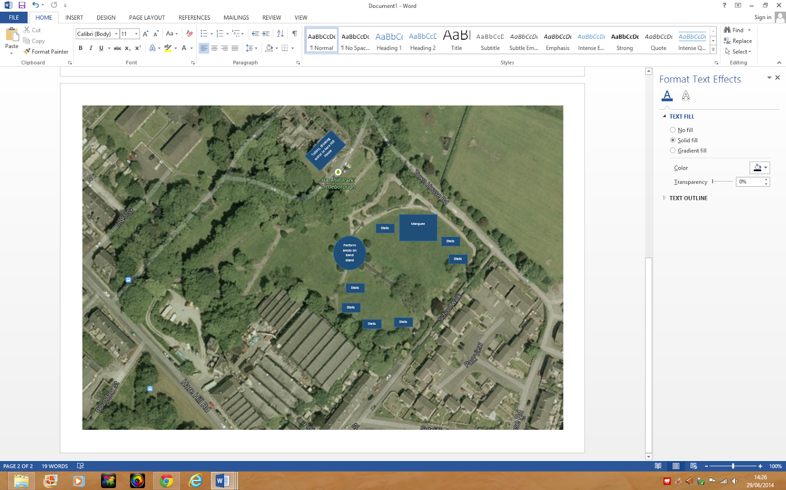

Appendix 4. Traffic Management Plan.

- LEAF stewards to manage movement within park.
- Contributors’ vehicles will be supplied with windscreen labels
- LEAF stewards to manage ingress/egress and parking for contributors.
- No public vehicle access within the park.
- Saturday and Sunday RMBC temporary road closures for parade and square performance.
- Crowd Barriers needed for Square performance on Sunday
- Build schedule 8 am start, all events finish by 17.00, get out by 20.00 (all daylight hours)

Appendix 5: Assumption form

- Based on previous events, it is assumed that no more than 1000 people at any one time will be present at any of the elements of the event. This assumption will be reviewed annually.

